Halloween 8 Use Responsive Web Design

In this exercise, you’ll enhance the home page you worked on in exercise 7 so it uses Responsive Web Design.

Specifications for a fluid design

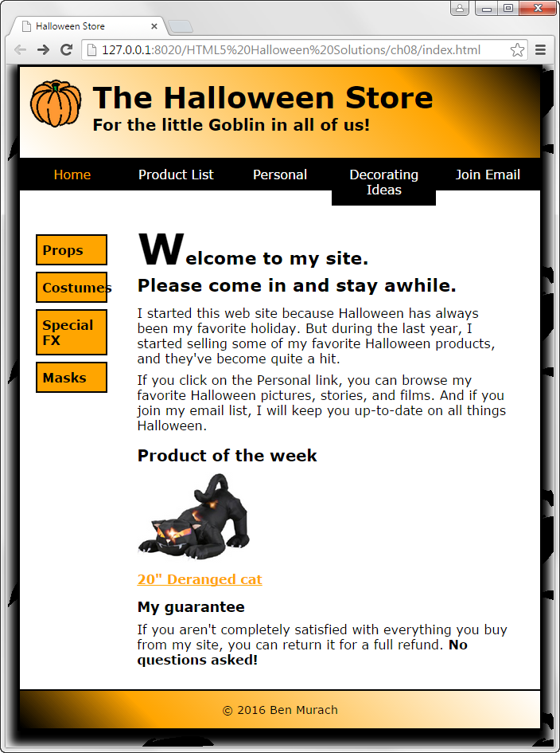

* Make a copy of the main.css style sheet and name it main_rwd.css. Then, modify the HTML for the page so it uses this style sheet.
* Modify the page so it uses a fluid layout. The maximum width for the page should be 960 pixels, and the page should occupy 95% of the browser window. Be sure to make the left and right margins and padding as well as the structural elements fluid. (Note: To get the boxes in the vertical navigation menu to size properly, you’ll need to specify the width on the ul element instead of the li elements.)
* If you used pixels for any top or bottom margins or padding, convert them to ems. In addition, if you specified any of the font sizes using pixels, convert them to percentages or ems.
* Make both of the images on the page scalable, and make sure that both images are limited in size to the width that’s specified in the HTML. In addition, make sure that the image in the header can’t be reduced to a width less than 40 pixels.

Specifications for a media query for a tablet in portrait orientation

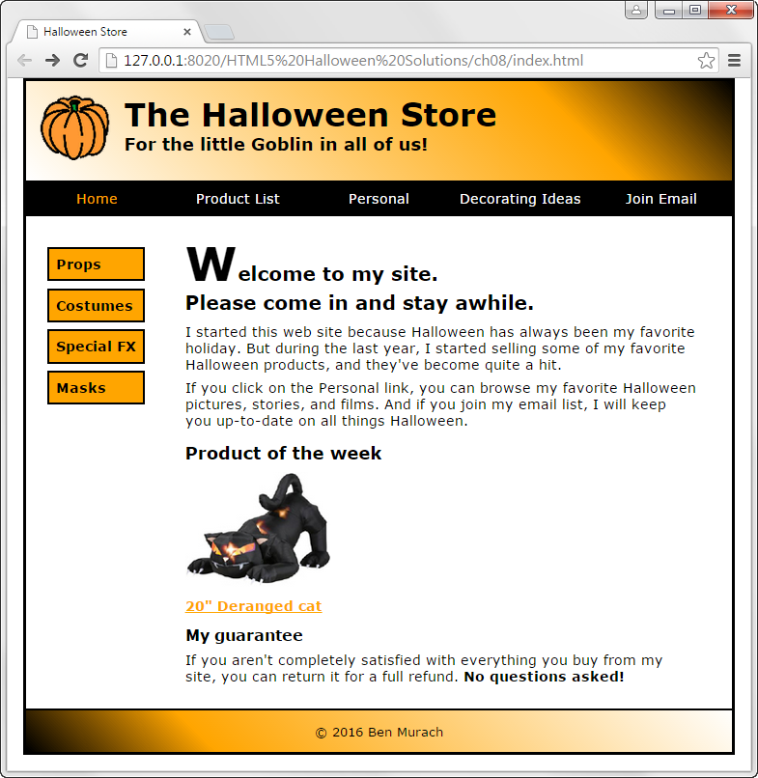

* Add a meta element to the page to control the viewport for media queries.
* Add a media query that will be applied to screens with a maximum width of 800 pixels. Then, add styles to remove the background image from the page, remove the shadow from the body, and reduce the size of all the fonts on the page to 90%.

Note: The page shown above was captured on a desktop so you can see the layout of the entire page.

Specifications for a media query for a mobile phone in landscape orientation

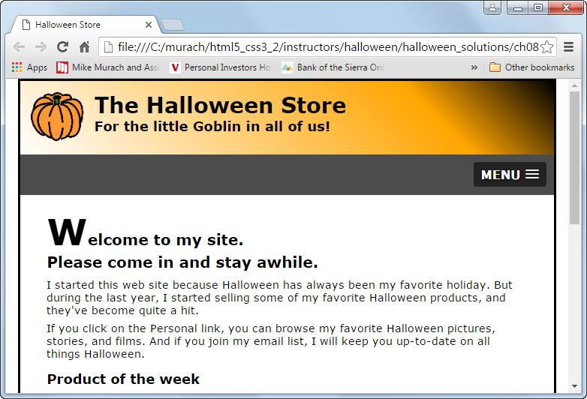

* Add a media query that will be applied to screens with a maximum width of 767 pixels. Then, add the HTML and CSS required to hide the navigation menu and display a SlivkNav menu in its place. You’ll find the slicknav.css file in the styles folder, you’ll find the slicknav.min.js file in the js folder, and you can get the jQuery library from the jQuery Content Delivery Network. Format the page so it appears in one column.

Note: The page shown above was captured on a desktop so it is an approximation.

Specifications for a media query for a mobile phone in portrait orientation

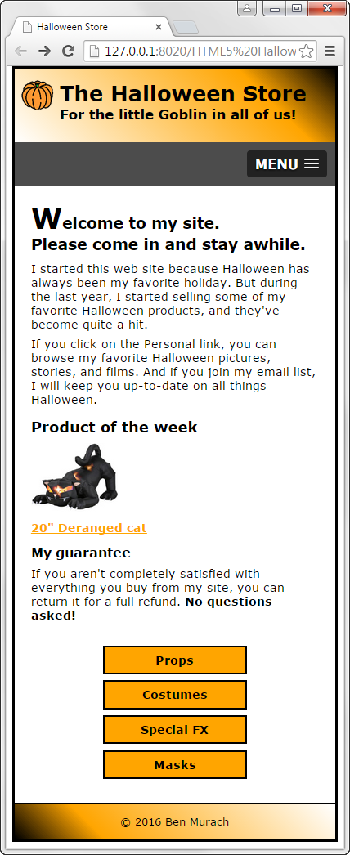

* Add a media query that will be applied to screens with a maximum width of 479 pixels. Then, reduce the font sizes of the headings in the header and the first heading in the section.

Note: The page shown above was captured on a desktop so you can see the layout of the entire page.